**Programming Project Report II**

Yvan Gihoza

010785599

**Problem Statement:**

Our second assignment was to introduce us with the keyboard command in OpenGL, we were to design a Minecraft looking game where the player could move around the world by creating cubes or removing them.

**Design:**

After going through the cube code of the professor I decided to use a giant cube as the world, and a small cube as the player. The codes were helpful, and I borrowed some in my project design

**Implementation:**

I started with the player and the world then I went with the keyboard features which was the rotation and the movements. My last approach was to do the add and remove of the cubes.

**Testing:**

I tested function by function and modification by modification. The cubes to see if I was able to draw it and then I started my coding.

**Conclusions:**

The project was successful as I was able to meet all the requirements required.

**Testing:**

**Drawing:**

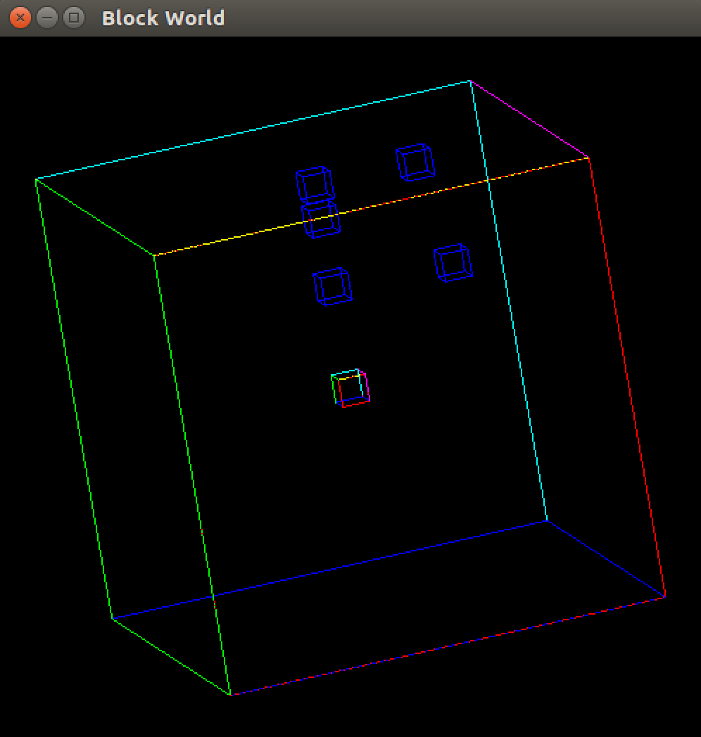

**Rotation Mode:**

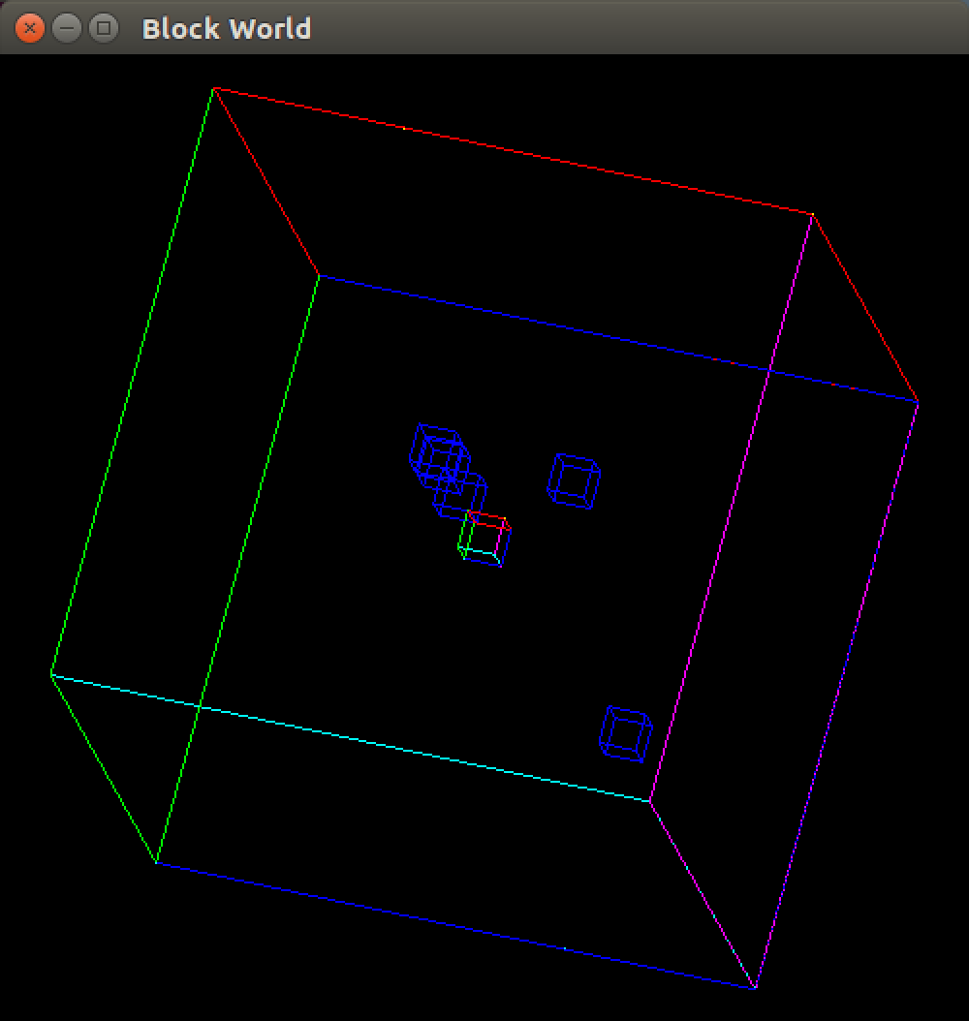

**Fly Mode:**

